

**Magnus Switch Overview**

15-07-2019

© For internal use



# Magnus Acquiring Transaction Flow:

### POS INR/DCC/EMI (Magnetic stripe, EMV, NFC)

* LITE POS/PC POS INR/DCC/EMI (Magnetic stripe, EMV, NFC)
* NON EDC (H2H) INR (Magnetic stripe, EMV, NFC)
* POS/Mobile BQR
* POS/Mobile UPI QR
* IPG INR/DCC
* IPG BQR
* IPG UPI QR

1. | 15-07-2019 | Internal| © Worldline

GBU | Magnus | Technology Development



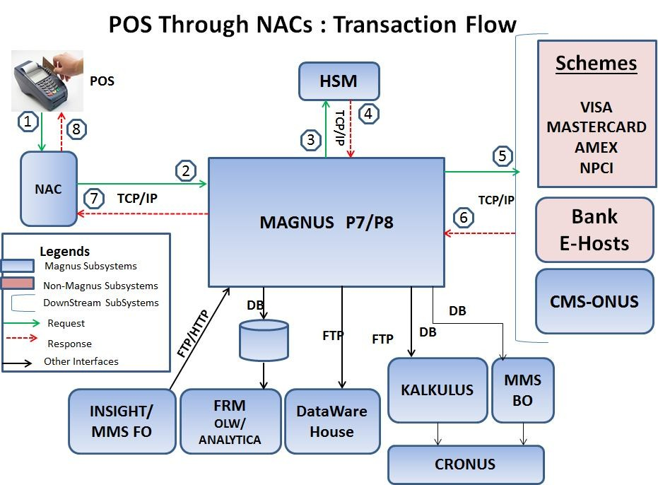

1. | 15-07-2019 | Internal| © Worldline

GBU | Magnus | Technology Development



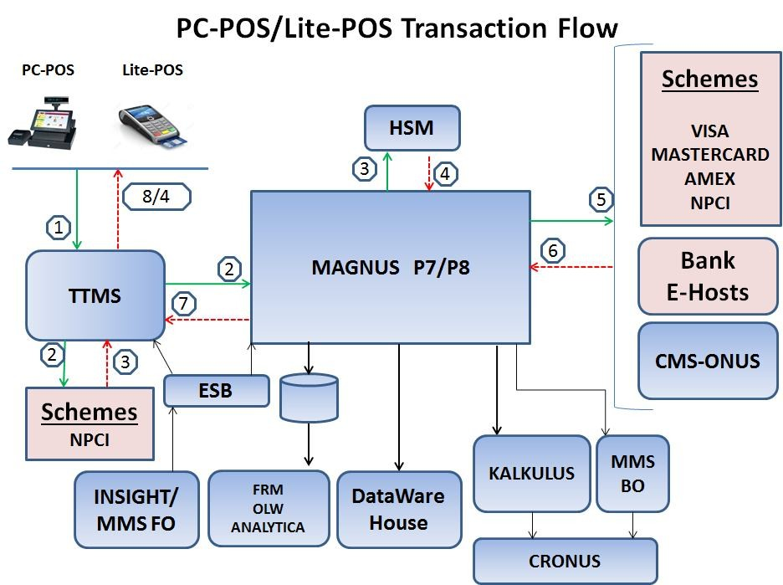

1. | 15-07-2019 | Internal| © Worldline

GBU | Magnus | Technology Development



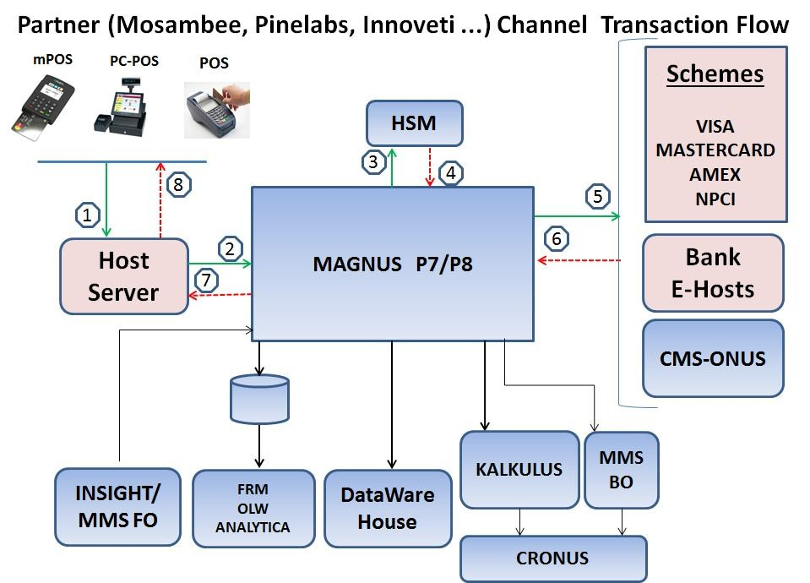

1. | 15-07-2019 | Internal| © Worldline

GBU | Magnus | Technology Development



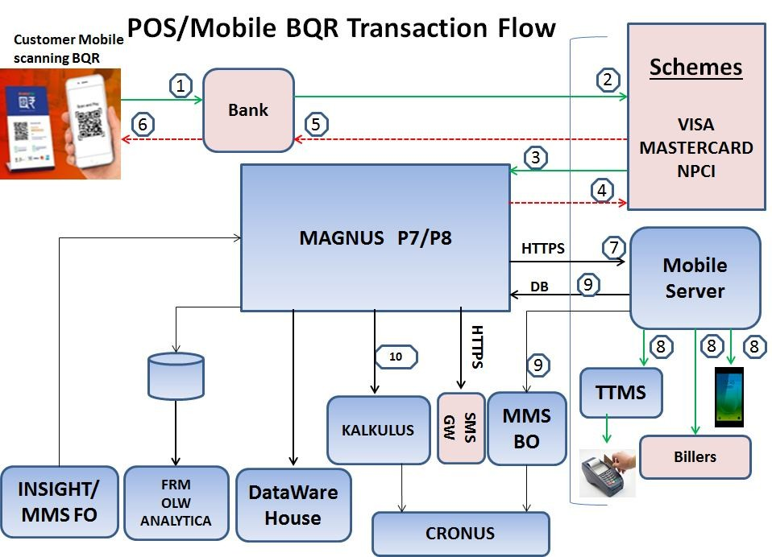

1. | 15-07-2019 | Internal| © Worldline

GBU | Magnus | Technology Development



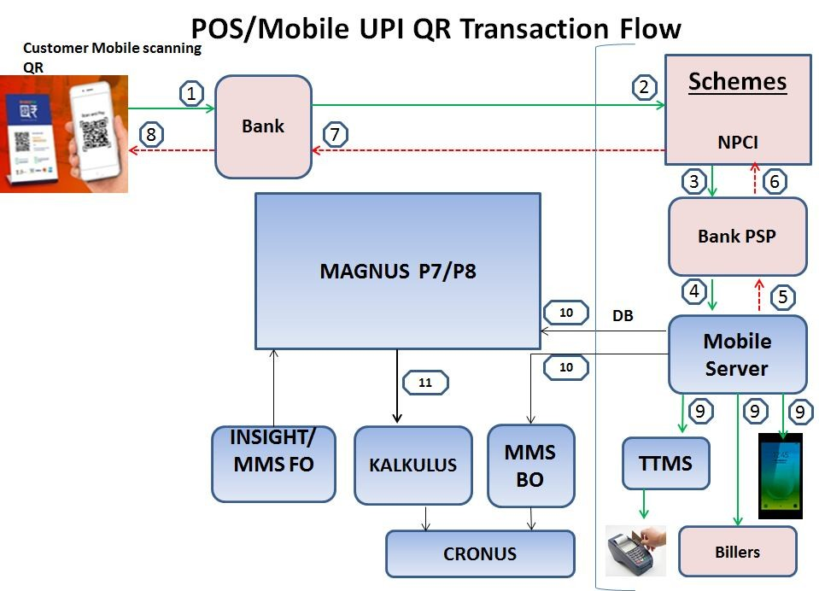

1. | 15-07-2019 | Internal| © Worldline

GBU | Magnus | Technology Development



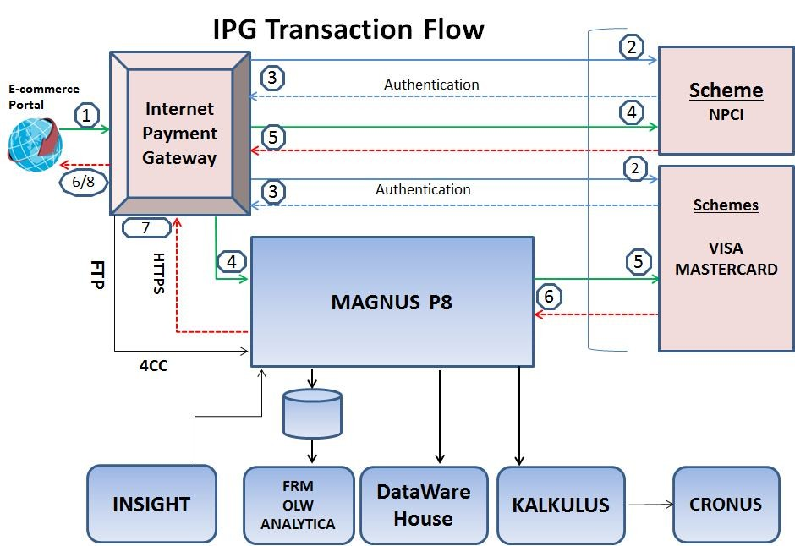

1. | 15-07-2019 | Internal| © Worldline

GBU | Magnus | Technology Development



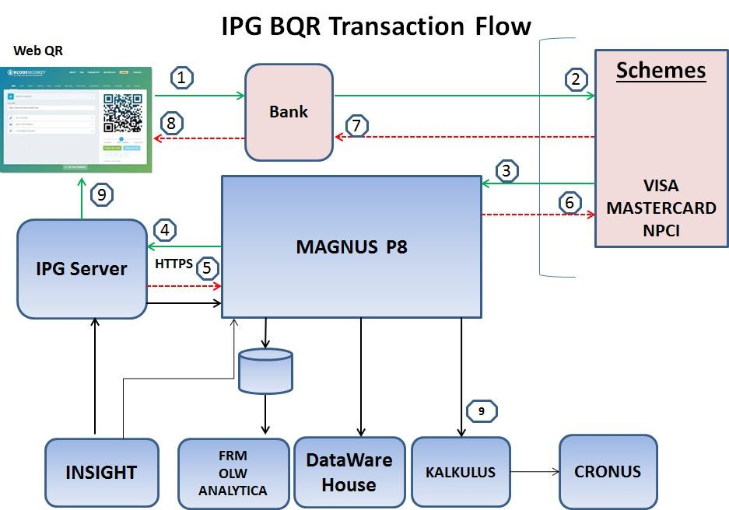

1. | 15-07-2019 | Internal| © Worldline

GBU | Magnus | Technology Development



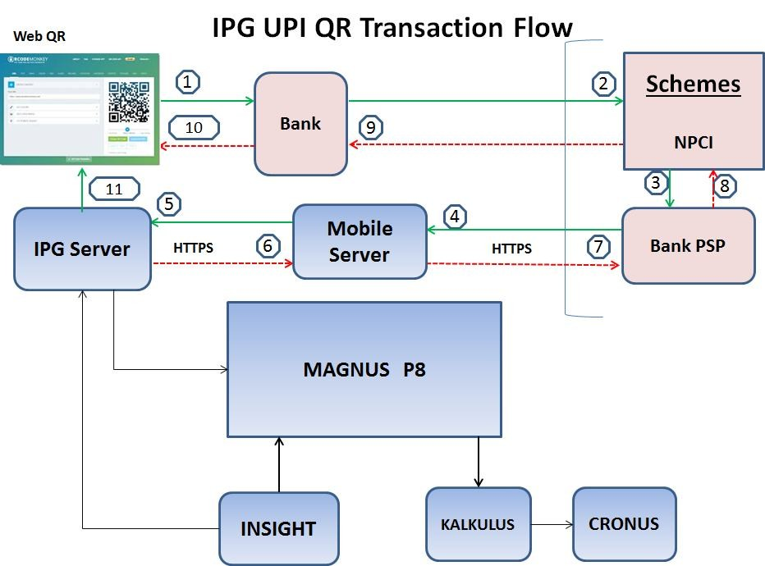

1. | 15-07-2019 | Internal| © Worldline

GBU | Magnus | Technology Development



# Magnus Switch

Connectivity and Interfacing

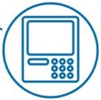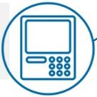

**Financial Switch**

Communication Protocols

**TCP/IP**

**HTTP**

**SSL**

**IPG Interfaces**

* ISO8583

**MMS Interfaces**

* Web-service

**POS Terminal Interfaces**

* ISO8583

**Other Host-Host Interfaces**

* ISO8583

**Core Banking Interfaces**

* ISO8583
* Web-service

**Card Scheme Interfaces**

* VISA
* MasterCard
* Amex
* NPCI(Rupay/JCB/CUPI/DFS)
* Private label Host

**TPS:** 250 **Maximum txn processed in single day:** 48,00,000

1. | 15-07-2019 | Internal| © Worldline

GBU | Magnus | Technology Development



# Bifurcations of Acquiring Transactions:

Lite POS

PC POS

**TTMS**

Lite POS

Schemes

**UBI**

**UBI CBI**

Magnus CMS

Lite POS

Bank Host

PC POS

POS

**MAGNUS P8**

**Partner Host**

**IPG**

**TCH**

**MAGNUS P7**

1. | 15-07-2019 | Internal| © Worldline

GBU | Magnus | Technology Development



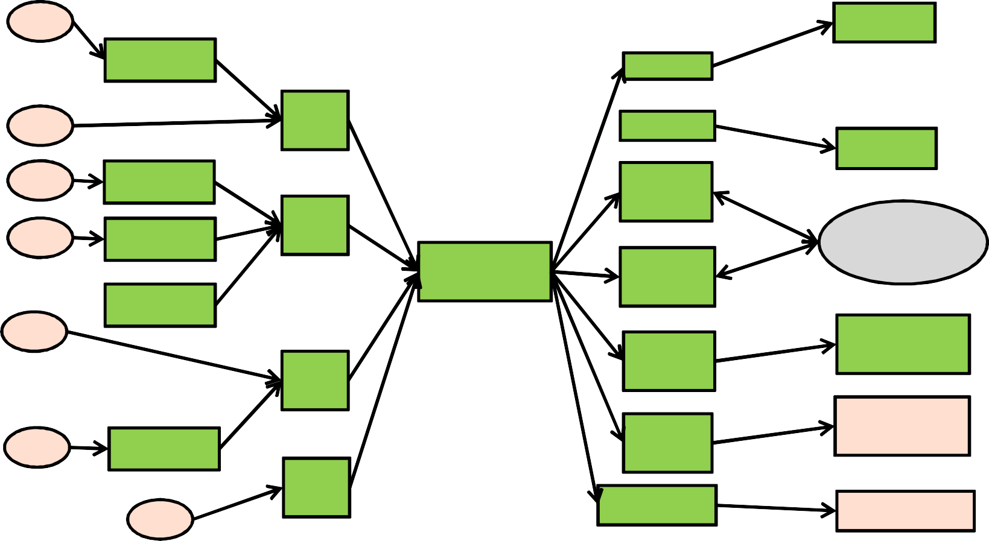

POS

PC POS

POS

Lite POS

Lite POS

**Magnus Interface Overview**

BQR

POS

SMS

H2H

ISO

FRM

FRM

TTMS

Scheme QR

TCH

PG2 ISO

VISA/MC/Rup

Schemes

ay

Dispatch

scheme

/Amex

IPG

POS

WEB POS

Loan ISO

CMS

Ehost

Magnus CMS

POS

H2H

EHOST

Bank HOST

PC POS

POS

PUN POS

PUNGRAIN

EGLOBAL

BQR

APP Ser

1. | 15-07-2019 | Internal| © Worldline

GBU | Magnus | Technology Development



# Basic Rules of Acquiring Transactions:

### Merchant & Terminal validation.

* + Transaction limit check
    - Per Transaction
    - Per Day
    - Per Month
    - Cash@POS Count & Amount.
  + BIN validation.
    - Restricted BIN
    - Restricted Key Entry BIN
    - Local/International check
    - ONUS transaction routing
    - OFFUS transaction Scheme routing (VISA/MCI/MDS/NPCI/Amex)

1. | 15-07-2019 | Internal| © Worldline

GBU | Magnus | Technology Development

# Magnus Team Structure:

## Switch Team:

### Bhagwat Thorat (Lead)

* + Amit More
  + Vishakha Salunkhe
  + Rupesh Patil
  + Nikhil Shrivas
  + Rupali Gaikwad

**CMS Team:**

* + Harshad Hadkar (Lead)
  + Aaradhy Choudhary
  + Santosh Jadhav
  + Pratibha Agarwal
  + Puneeta Goyal
  + Bhushan Harekar



1. | 15-07-2019 | Internal| © Worldline

GBU | Magnus | Technology Development

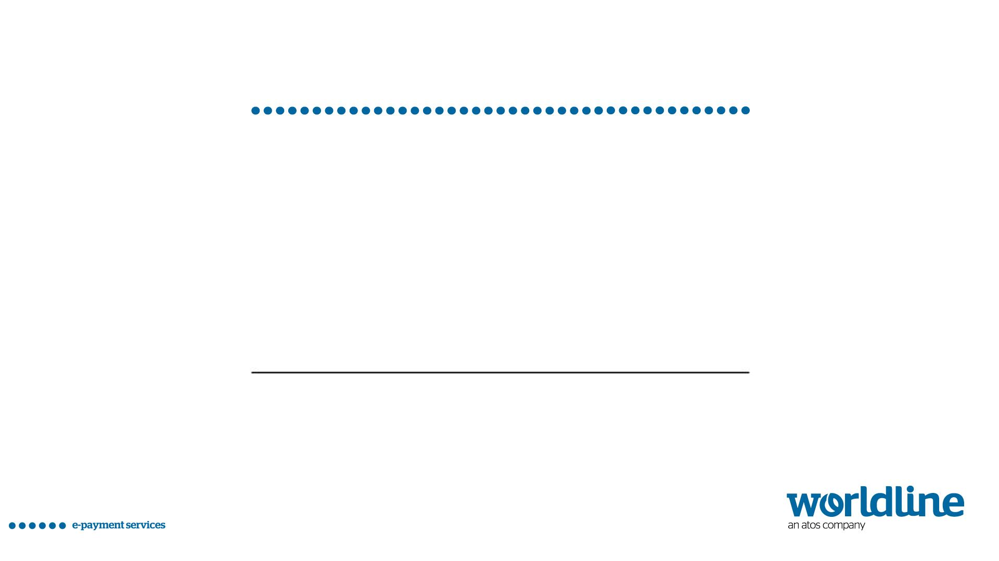

## Thanks

#### For more information please contact:

**Vivek Mahapatra**

#### T+ 91 22 7198 0000

M+ 91 98191 78116

[vivek.mahapatra@worldline.com](mailto:vivek.mahapatra@worldline.com)

Worldline is a registered trademark of Worldline SA. ©2017 Worldline. Confidential information owned by Worldline, to be used by the recipient only. This document, or any part of it, may not be reproduced, copied, circulated and/or distributed nor quoted without prior written approval from Worldline.

#### 15-07-2019

© For internal use